**AWS VPC**

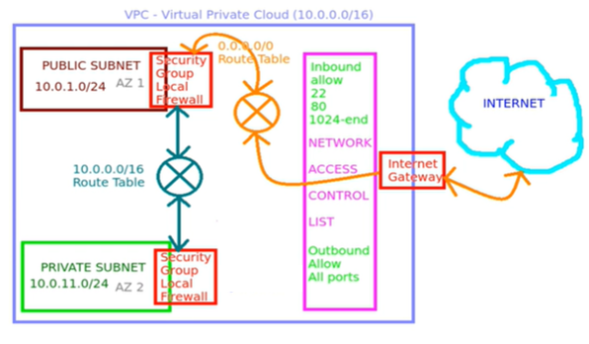

1. **Create VPC**

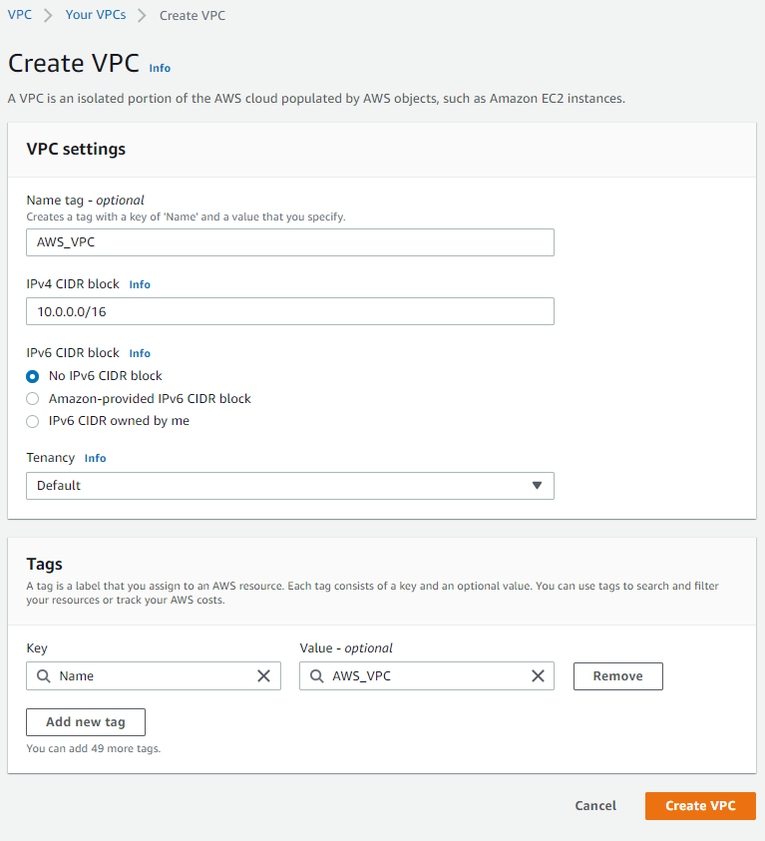

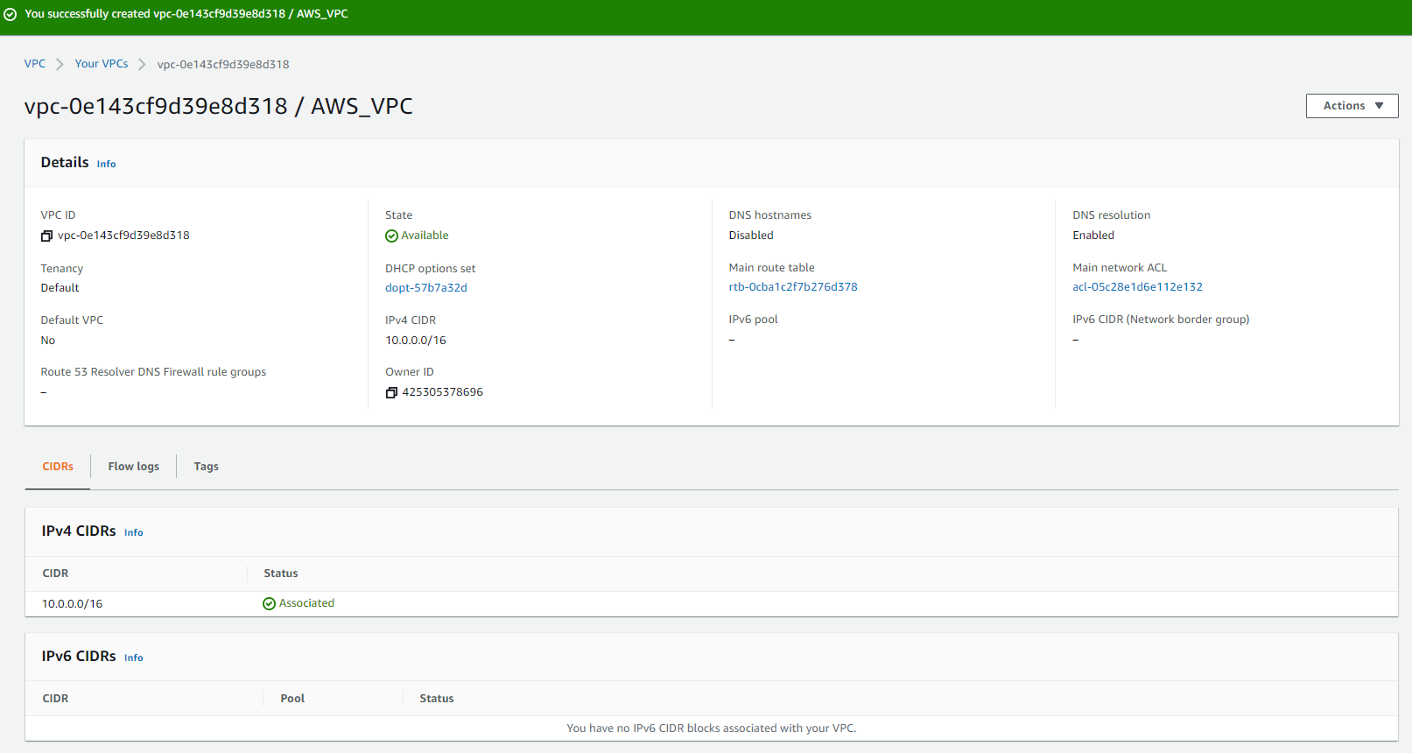

1. **Next we are going to create subnets**

**First we are going to create private subnet.**

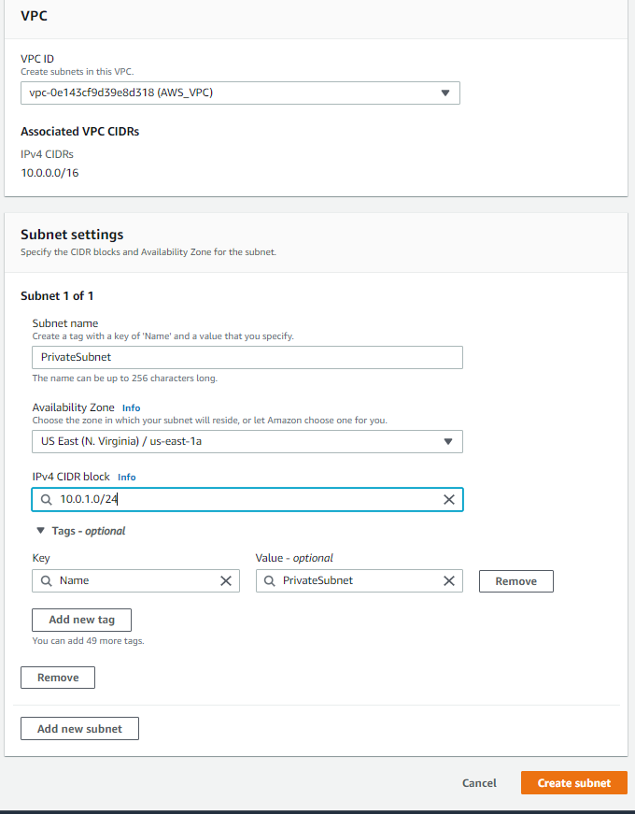

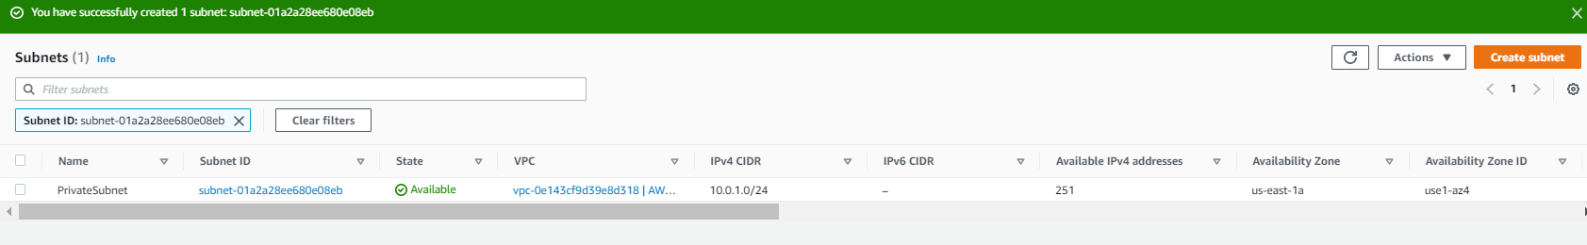

**Similarly Create Public Subnet.**

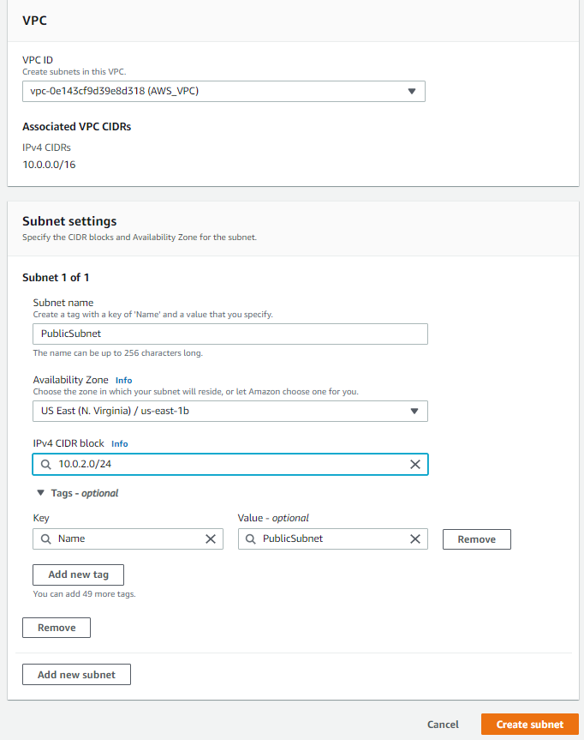

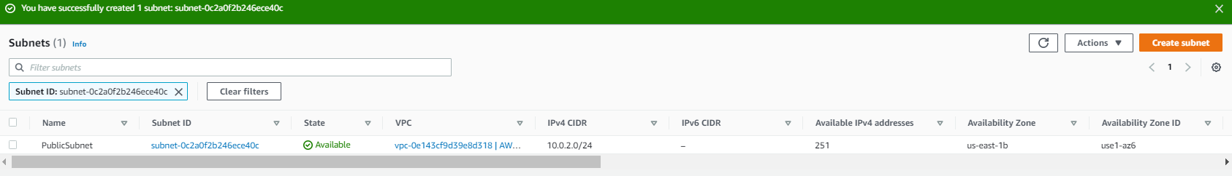

1. **Creating Route Tables.**

**Create a PublicRT**

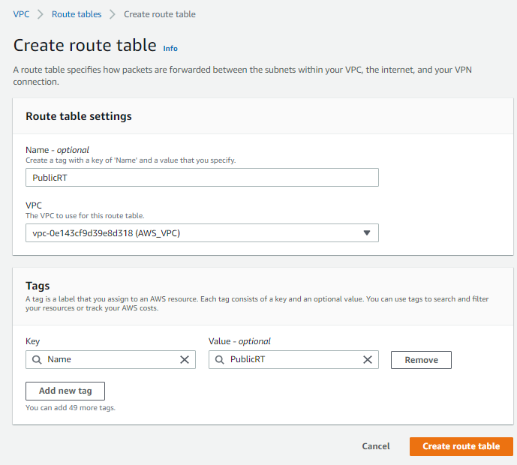

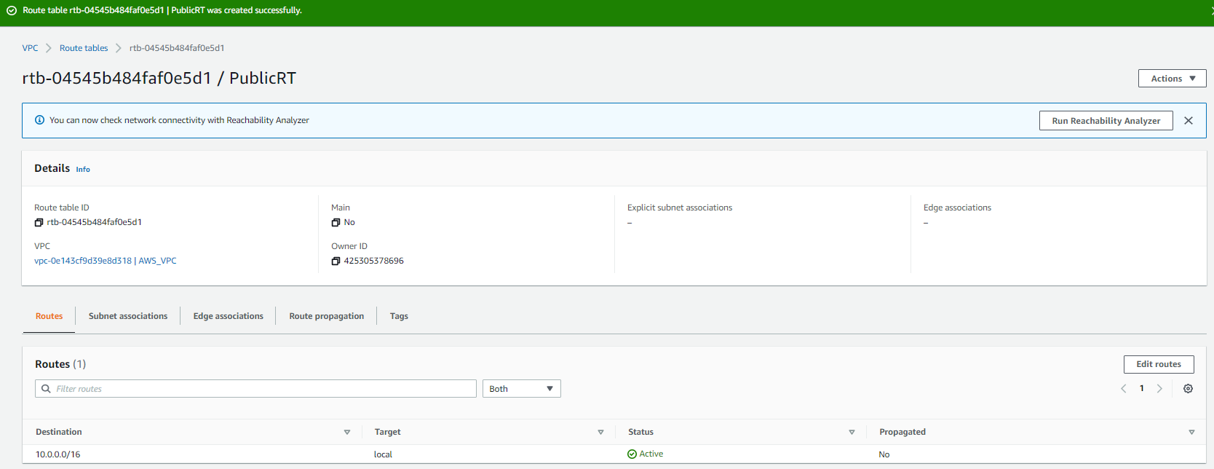

**Create a PrivateRT**

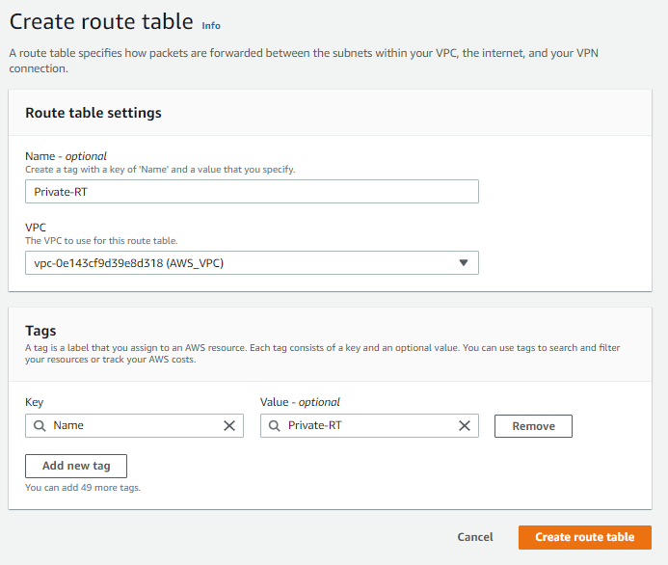

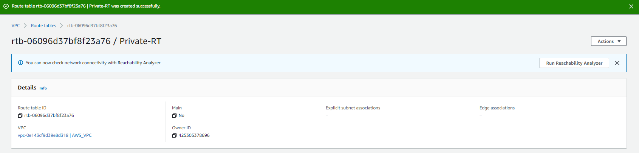

**After creating the subnets we have to do subnet Association.**

**Associate Public-RT with Public Subnet and**

**Associate Private-RT with Private Subnet.**

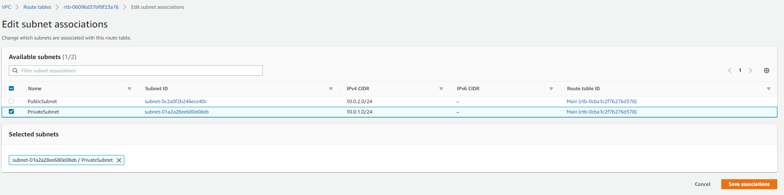

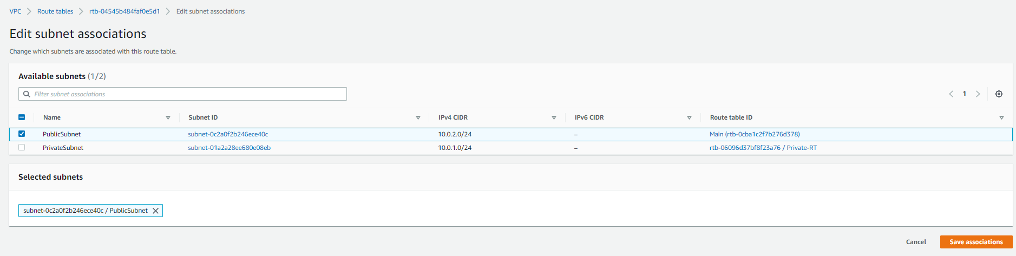

1. **Next, we are going to create Internet Gateway.**

**Create a new internet gateway and attach it with the VPC**

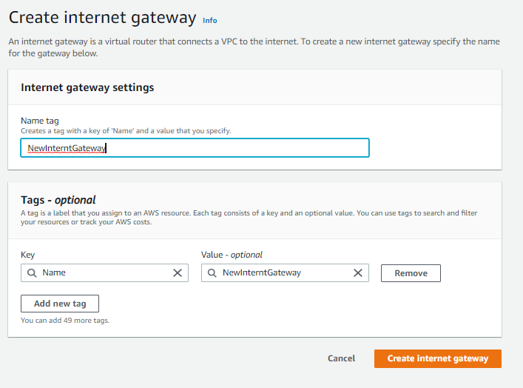

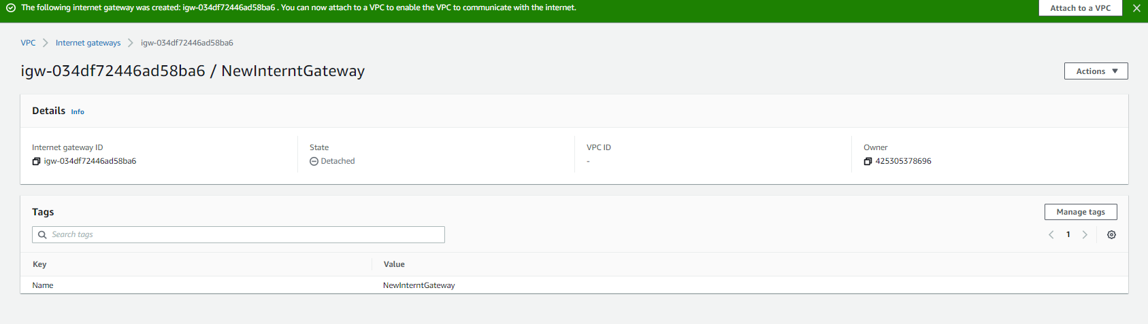

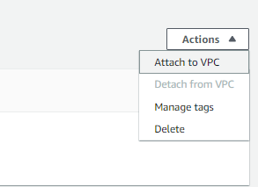

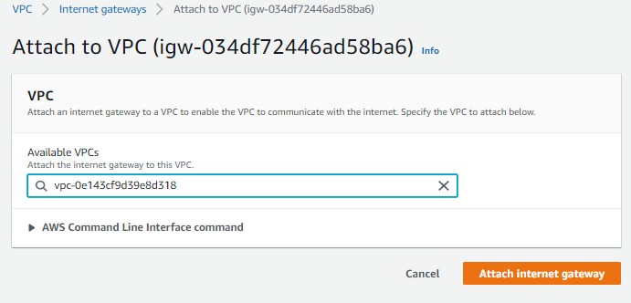

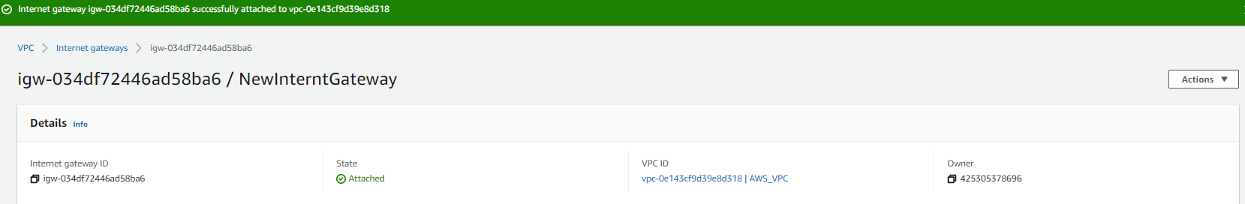

1. **Next Route the Internet Gateway with the Public RT**

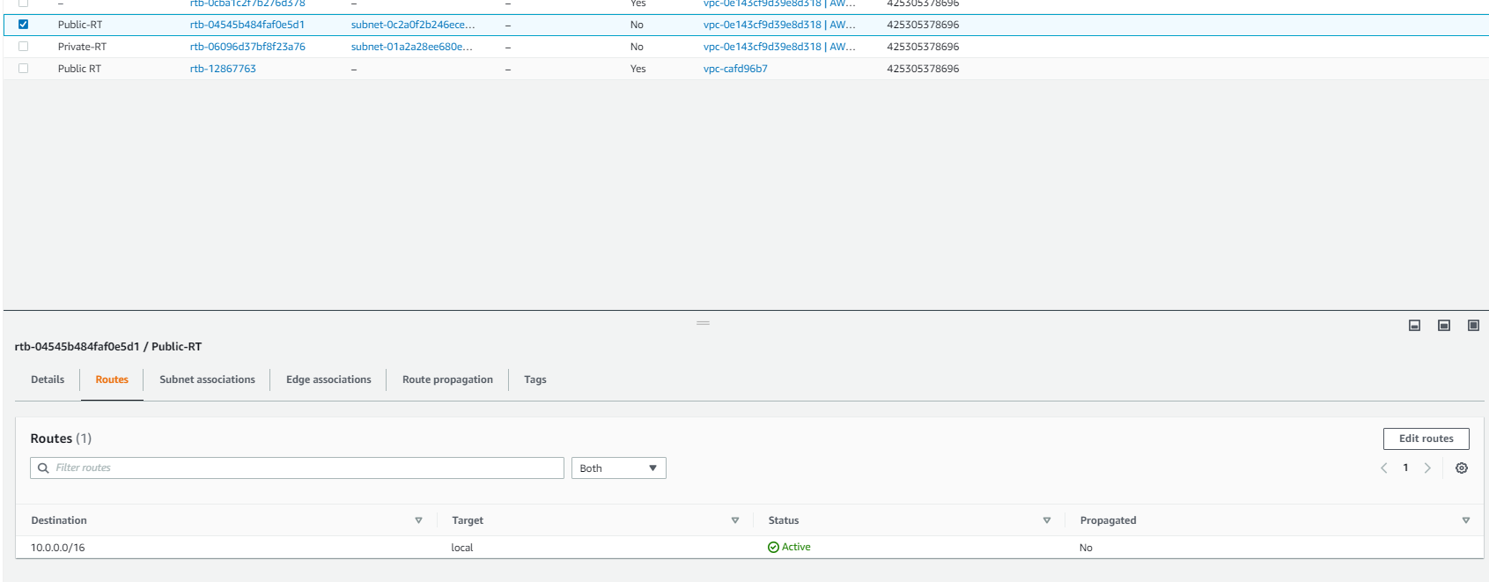

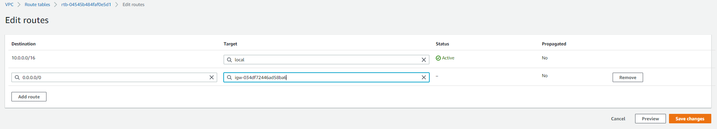

1. **Create two Instances**

**First Create a private instance**

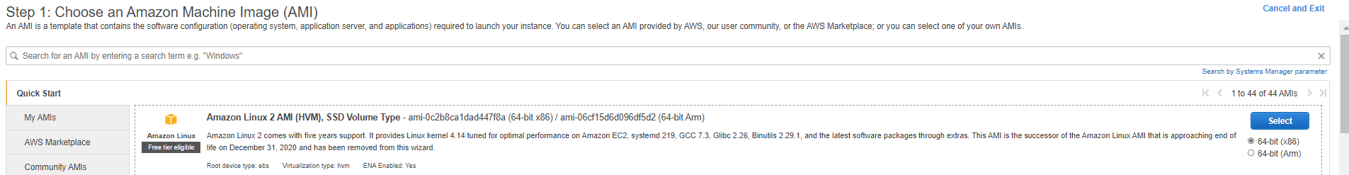

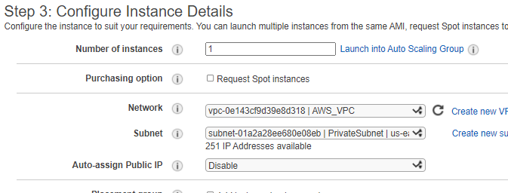

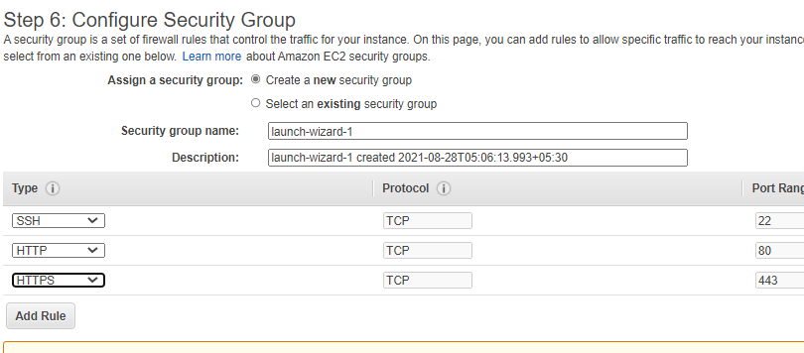

**Likewise create a Public Instance**



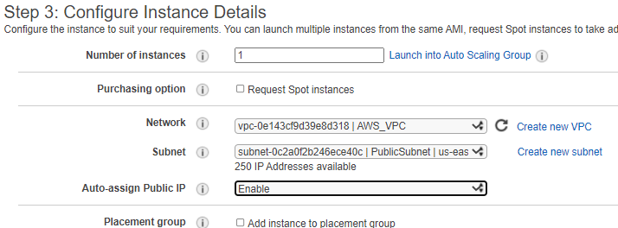

**Public and Private Instances have been created**

**Let us try to communicate with the public Instance**

**Go to terminal where u have the .pem file**

**Take the connecting command from the public instance and put it in CMD**

ssh -i "Pk-VPC.pem" ec2-user@23.22.89.181

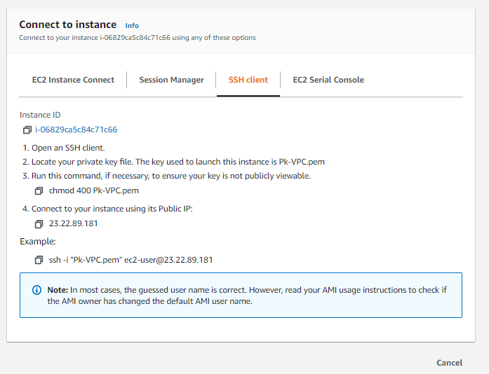

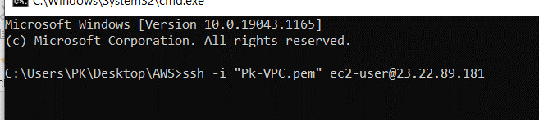

**The Public instance has been connected**

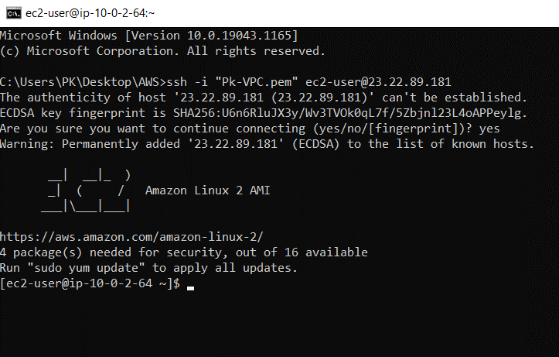

**Check it by typing the command type ping google.com it will start exchanging the packets.**

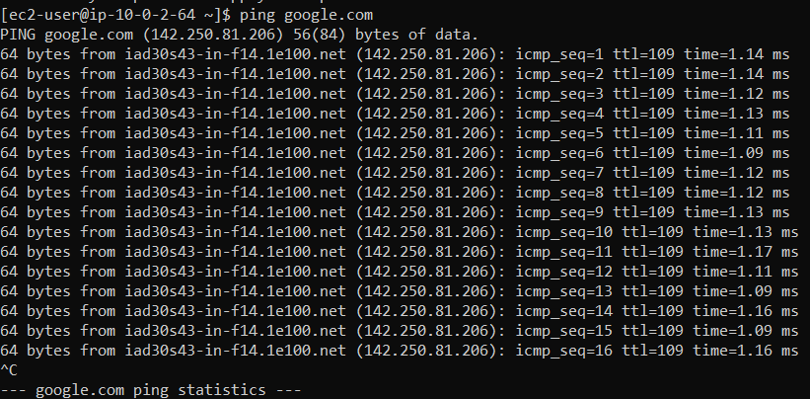

**Similarly try to connect with the Private Instances**

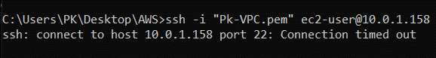

**It will not connect because there is no IP address assigned to this instance.**

1. **We are going to Create a NAT Gateway**

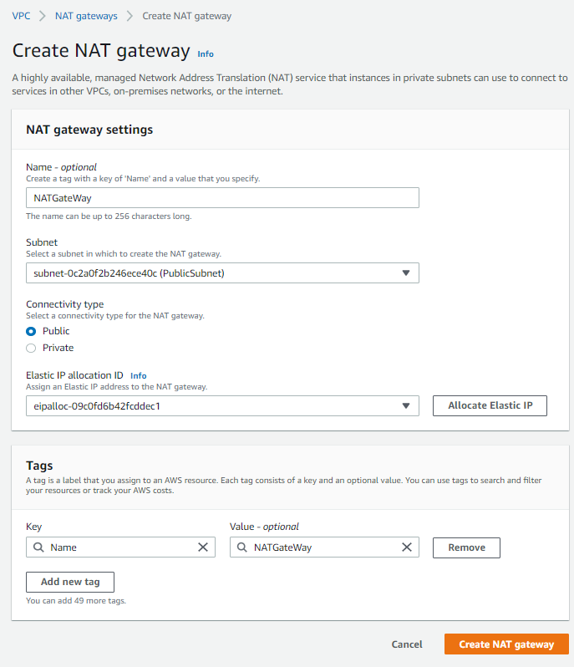

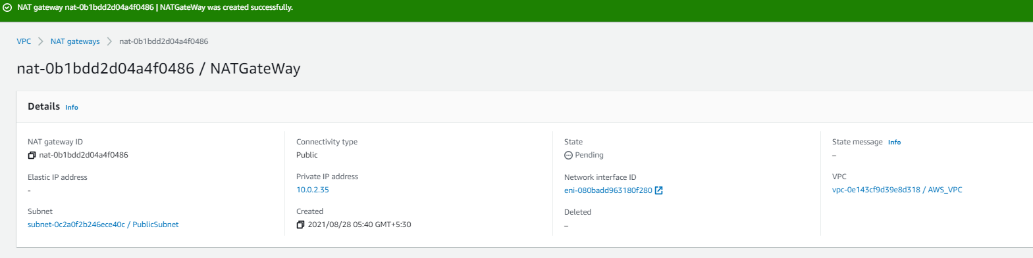

**Once the NAT Gateway is created route it with the private route table**

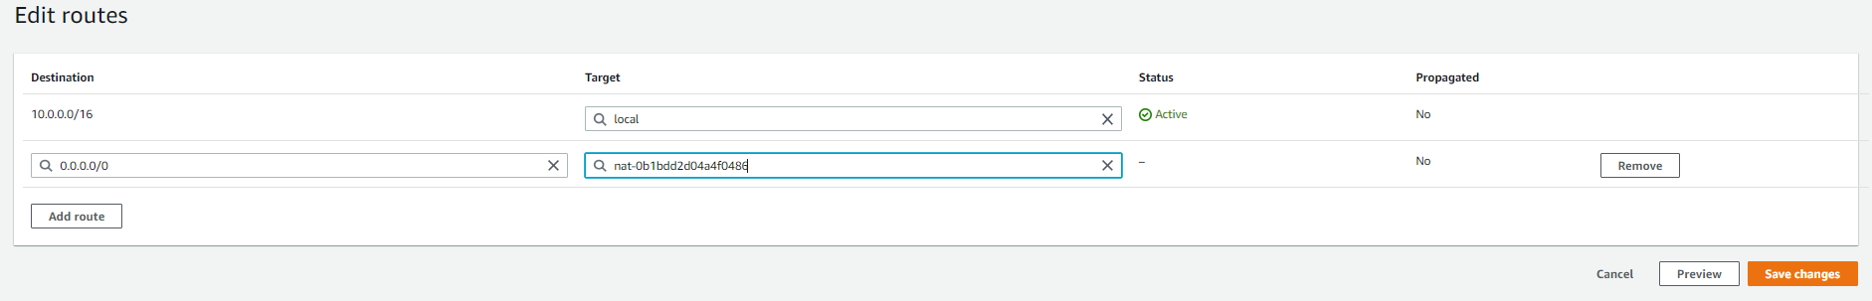

**Now let us whether our Private Instance have the access to the internet as it get connected to the public network through NAT Gateway.**

**Sudo su –**

**vi my.pem**

**(insert the key which is required to connect the private instance)**

**ecs+:wq+enter**

**chmod 400 abc.pem**

s**sh -i "abc.pem"** [**ec2-user@10.0.1.158**](mailto:ec2-user@10.0.1.158)

